Plugins
Tasker's power is extended further by the use of it's plugin API.
https://tasker.joaoapps.com/plugins-intro.html
This allows either an app already can be programmed to utilize this API subsystem and provide data to Tasker, create Event & State contexts as well as be controlled from. It is also possible to make apps specifically to use this API, which can then extend the power of Tasker even more! An example of this, is the now developer of Tasker, Joaomgcd!

AutoApps Suite
The AutoApp suite of plugins truly extend Tasker's power much further. From getting information on alarms set on your device, to fully controlling your device with your voice, automating UI navigation, extracting data and information from websites and APIs, all the way to formatting text and arrays and customizing settings normally requiring root.

AutoAlarm
A plugin to get information on Alarms set
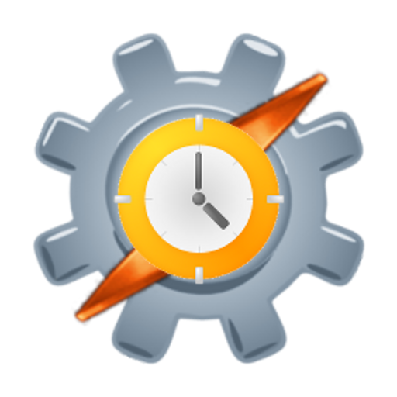AutoAlarm

AutoApps
Essential app to get the most out of the AutoApp plugin suite.
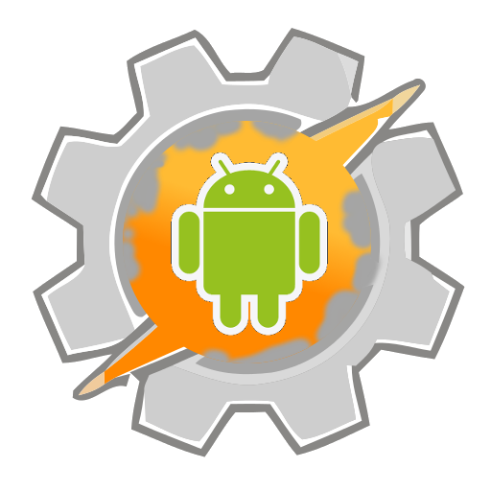AutoApps

AutoCast
Plugin for ChromeCast enabled devices.
AutoCast

AutoContacts
Read your contacts information to use in Tasks
AutoContacts

AutoInput
Automate UI activities through Tasker.
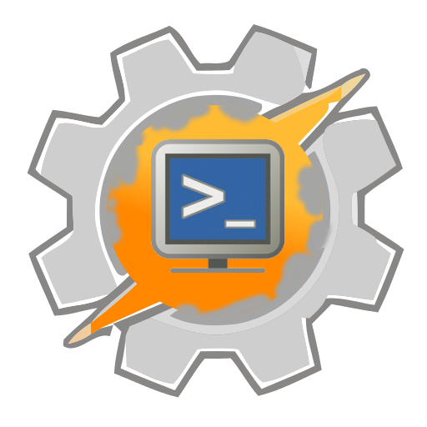AutoInput

AutoLocation
Improved location features for Tasker.
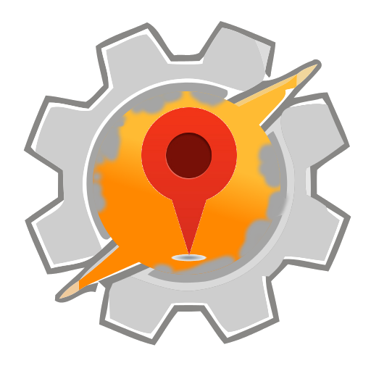AutoLocation

AutoNotification
Control your notifications and react to them. Intecept toasts!
AutoNotification

AutoRemote
Send messages and files between your Tasker. Can also be used in Chrome, from Curl and others.
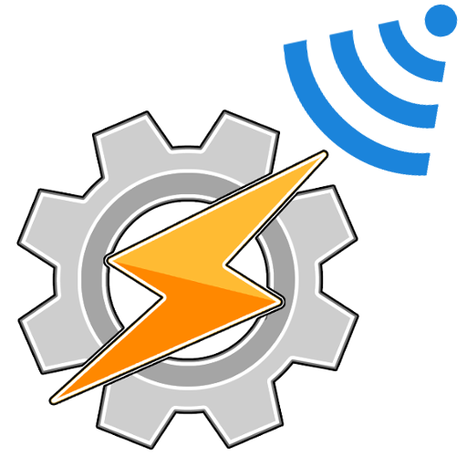AutoRemote

AutoShare
Gain more control over content you share when tapping “Share With”.
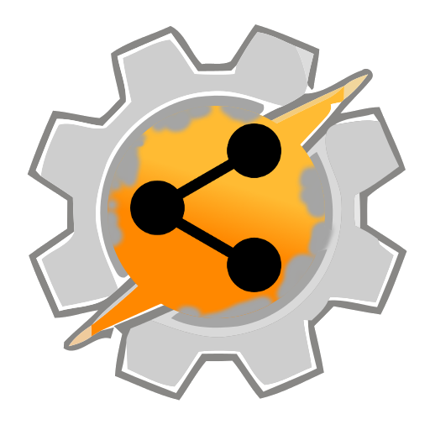AutoShare

AutoSpotify
Control your Spotify from Tasker!
AutoSpotify

AutoTools
A swiss army knife of features missing from Tasker.
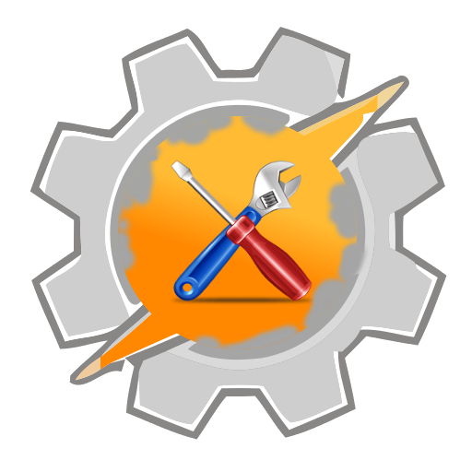AutoTools

AutoVoice
Total voice control! Including Google Assistant/Home and Alexa support!
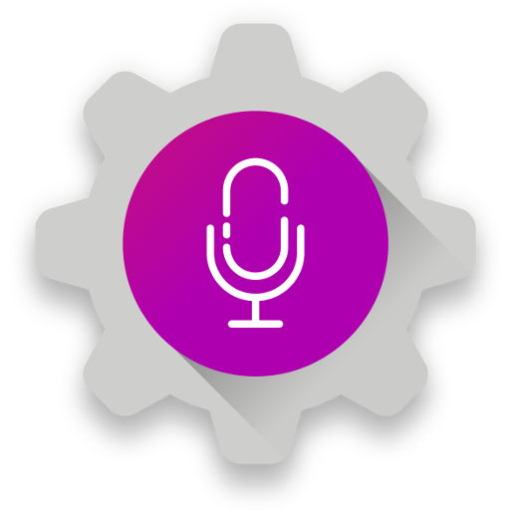AutoVoice

AutoWear
The essential plugin for WearOS users!
AutoWear

AutoWeb
Access those APIs you see on your favorite services!
AutoWeb

Join
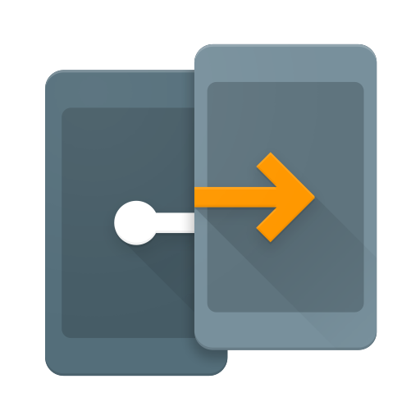Join

Media plugins
Various plugins that offer media facilities; not just playing music and video!

Anymote Universal Remote
Control many kinds of devices either with a dedicated hub for IR devices, or many WiFi devices directly from app
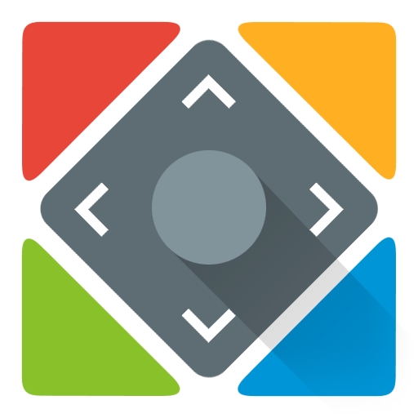Anymote Universal Remote

Background Video Recorder
Record video from either camera in stealth. Useful for personal protection. Not a plugin, per-se, but has callable activities Tasker can use with ease!
BVR by Kimcy

Microphone by Wonder Grace
Relay audio from phone, headsets and BT media devices. Useful for listening in on phone mic from BT headset
Microphone by Wonder Grace

TinyCam Pro
Access a variety of web cams and combine them into one place.
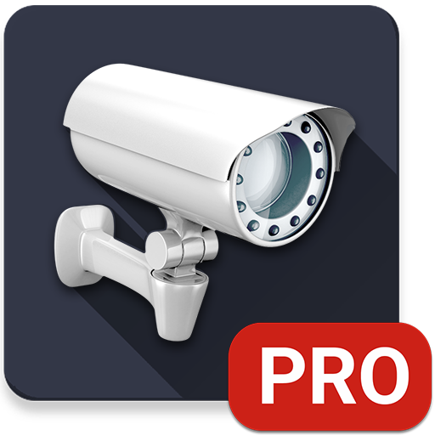TinyCam Pro

Wear devices
Plugins for WearOS, TicWear and maybe Tizen (only watchmaker for Tizen at present).

Watchmaker
Powerful, cross platform tool for building watchfaces of all kinds!
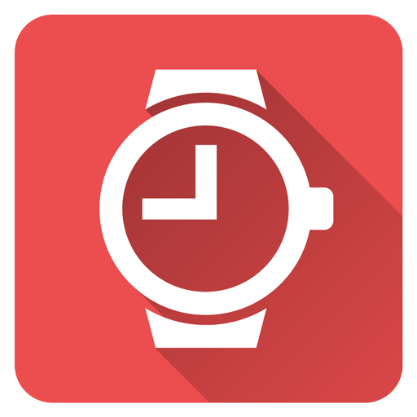Watchmaker Watchfaces

Wear Codes
Simple & fast access to QR, Bar and other codes for your day to day needs
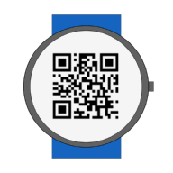WearCodes by Codechimp

WearTasker
A simple & easy method to run favorite tasks from Watch
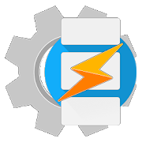WearTasker

Utilities
Various utilities that also offer Tasker support!
Image | Sleep as Android | Description
Image | Time Tracker by Chris Drake | Description

Development
Image | QTPython2/3 | Description
Image | SL4A/Python4Android | Description
Image | Termux | Description
Today this page has been viewed times today!

