AutoApps Suite

The AutoApps suite of plugins increase Tasker's power further. From controlling your phone with your voice all the way to fully automating the UI. The idea of having lots of additional apps and icons in your launcher may be off putting. However if you install and use the AutoApps App itself, you can configure it to hide all other Auto-plugins from your launcher. Neat, eh! However, it is important to note that plugins actually take a burden off of Tasker and can have their own priorities and services. That way, they do all the brunt work and provide Tasker just what you need!
There are a lot of apps that provide Tasker plugin facilities, however over my few years of using Tasker, I have found that Joaomgcd not only provides a powerful suite of plugins and features, but provides some of the best support from a developer one can get!

Selling Points

AutoAlarm | Key Features
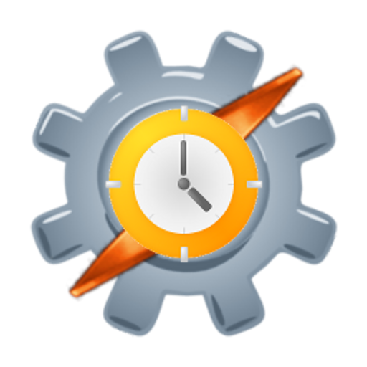Image | * Get detailed information on alarms set on your device  * Very simple to setup, no configuration required!
AutoApps | Key Features
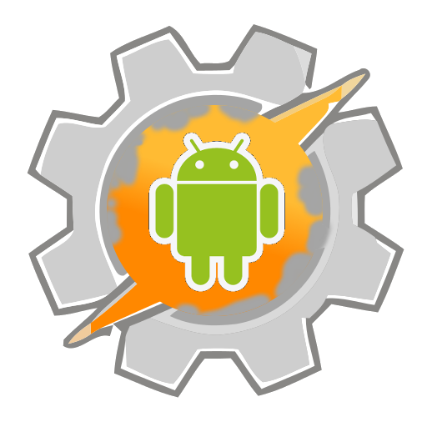Image | * Command Hub for all AutoApp plugins  * Store front for easy access to all AutoApps  * Licence app for IAPs and subscriptions  * Access Beta testing and Alphas  * Get additional help and support
AutoCast | Key Features
Image | * Cast web pages, music, video and images  * Best Guess to play various media such as YouTube  * Control media playback  * Text to speech output  * Get information of playing content
AutoContacts | Key Features
Image | * Get detailed information about contacts stored on your device  * Various filters to only retrieve the data needed  * Supports SNS contacts
AutoInput | Key Features
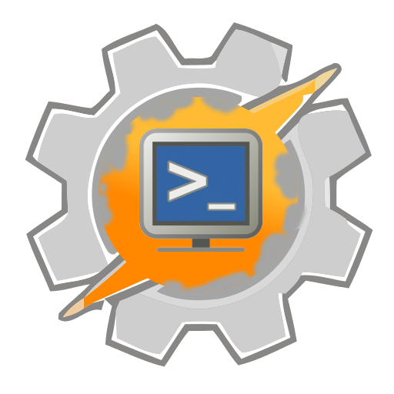Image | * Standalone feature to Auto Dismiss Keyguard on SmartLock.  * Get UI update and action events and retrieve app text contents  * Automate pressing areas of your display, navigate menus and press buttons.  * Perform gestures  * Wake up display automatically  * Put display to sleep without affecting SmartLock  * Replicate behavior of virtually any accessibility app on the market
AutoLocation | Key Features
Image | * Easily create geofences to mark as a zone for various things  * Perform background GPS polling to keep up-to-date data  * Convert GPS to address & vice-versa  * Perform Nearby searches for local places of interest  * Detect motion type from driving, train, walking & cycling
AutoNotification | Key Features
Image | * Standalone feature to block notifications on Android 7+  * Control Notification channels on Android 8+  * Intercept any apps notifications to use or replace  * Intercept any apps toasts  * Query current notifications and obtain info  * Take action on notifications such as press buttons or cancel them  * Create fully customisable Notifications specific to your needs  * Create custom QuickTiles and assign them to do whatever you want
AutoRemote | Key Features
Image | * Easily send messages and files between devices  * Supports sending and receiving IFTTT webhooks  * SSH Support to send messages and files to Linux  * Chrome browser plugin, send and receive messages in Chrome  * Not limited to Android, can send messages from curl, wget and other web crawlers  * Send notifications to other Androids with AutoRemote  * Remotely open web pages on other Androids with AutoRemote
AutoShare | Key Features
Image | * Share URLs, Text, Images and other content from any app with anything you want  * Share stuff from Tasker with other apps  * Intercept other app shares and customize them  * Process text prior to sharing automatically  * Add send and receive shares to your standalone apps
AutoSpotify | Key Features
Image | * Search for tracks and playlists to easily play in Spotify  * Create custom playlists from your searches  * Control playback of Spotify  * Get track, album and playlist information and images
AutoTools | Key Features
Image | * Text & number processing capabilities to format, sort and filter text & numbers of various types  * Action report and wait states to provide progress of operations  * Easy management of Arrays to sort and merge and more  * Custom Chrome Tabs  * Control flashlight for Strobe, Morse Code or Torch  * Connectivity checks for mobile, wifi and internet  * Various, pre-made, customisable dialogues to use in Tasks  * Perform gestures within Tasks and react to them  * HTML, JSON and XML scraping facilities  * Set wallpaper, get image information and Muzei support  * JSON reading and writing support  * Act as launcher, create your own launcher  * Access logcat information on Android 7+ without root  * Perform various math functions  * Send images to Google OCR to convert into text  * Perform various regexp operations  * SSH support to run commands and send/receive files  * Secure Settings support to tune various system settings otherwise needing root  * Access raw data of various sensors onboard your device  * Perform time operations to convert to and from various dates and time frames  * Create custom toasts  * Create custom vibrations  * Create, use and customise web screens that can perform many different actions
AutoVoice | Key Features
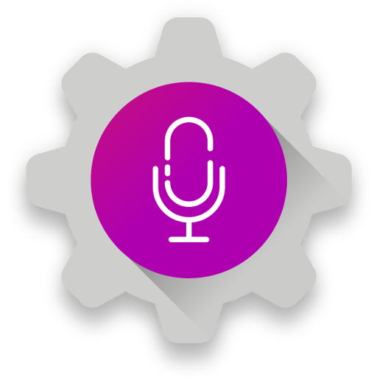Image | * Control your device by voice with customisable options  * Intercept and react to voice command sent to Google Now/Search  * Alexa support as a standard & smarthome skill  * Google Assistant support with cards, carousels & more  * Also works with Google Home  * Natural Language support for much greater control  * Issue voice commands on other devices remotely  * Detect noise to react to  * Could be used to create your own, personalized assistant  * Works over Bluetooth
AutoWear | Key Features
Image | * Create various screens with buttons, lists, images, swipe actions and more  * Ceate floating icons that are persistent with various actions  * Control settings such as Bluetooth, Wifi & screen brightness  * Secure Settings support to change options normally requiring root  * React to events such as screen on/off, shake, steps, sensors and more  * Get information from the watch such as steps, heartrate, brightness from sensor, orientation, battery and more  * Run command option to assist in WearOS 2 and rooted devices
AutoWeb | Key Features
Image | * Access web services that offer Restful, JSON & XML based APIs  * Large set of APIs already available to download and use  * Easily create your own APIs with guided setup  * Supports various authentication methods  * Supports almost all HTTP methods (POST, GET, PUT, FETCH, DELETE, etc) as well as custom headers  * Supports various mime-types and encoding
Join | Key Features
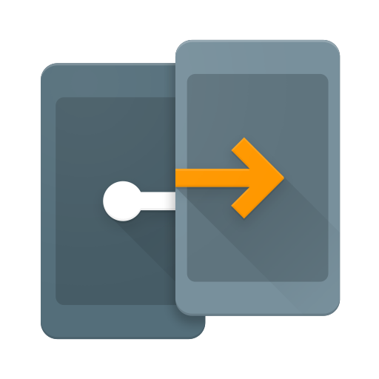 | Key Features

Demystification
Why an AutoApps Hub? Why so many separate apps? Why can't it just do a simple IAP? What happened to AutoRemote, AutoShortcut, AutoBarcode full? My purchases don't work? It's a scam, he gets you to install all these apps to improve his ranking… etc. etc. etc.
I've read most of them, laughed at some of them and believe I understand enough to explain to most that do not understand why there is this plethora of difference vs. apps you may have purchased/subscribed to etc. In a nutshell, Joaomgcd has been releasing apps on Play for a long, long time & Google change stuff all of the time!
For a demystification of AutoApps, go here!

